Guide to the Platform

EPIC Assessment Tools

2020-1-HU01-KA202-078669

We publish this guide under the Attribution-Non-Commercial-ShareAlike 4.0 licence. We encourage you to use and remix this guide to suit your needs. We simply ask that you attribute the source and provide the same licence conditions in your products. If you do use this content, please share your experiences with the authors (<https://epic-project.net/>) so these can be included in ongoing research into communication and media project evaluation.

**Who is this Platform Guide for?**

This Guide has been developed based on the Erasmus partner’s experience of developing and using the EPIC Self-Assessment system. This assessment system was developed as part of the Erasmus+ project called **Educational Package for SMEs To Increase Their Innovation Capabilities and Productivity**, known as **EPIC**.

EPIC has been designed for use by vocational education trainers, coaches and mentors, Human Resource experts with responsibility for developing managers and employees within the context of innovation

Five parts make up the on-line EPIC Self-Assessment System:

* EPIC Self-Assessment: Business Management
* EPIC Self-Assessment: Communication
* EPIC Self-Assessment: Ideation
* EPIC Self-Assessment: Innovation
* EPIC Self-Assessment: Digitalisation.

**Acknowledgements**

This Guide was produced with the involvement of the following organisations as part of an Erasmus+ under the Key Action: Cooperation for Innovation and the Exchange of Good Practices:

* Trebag Intellectual Property and Project Management Ltd (Hungary)
* Slovensky Plastikarsky Klaster (Slovakia)
* Dekaplus Business Services Ltd (Cyprus)
* Aintek Symvouloi Epicheiriseon Efarmoges Ypsilis Technologias Ekpaidefsi Anonymi Etaireia (Greece)
* Tabela Espontanea Unipessoal Lda (Portugal)
* Exponential Training & Assessment Limited (United Kingdom)
* SC Energom Srl (Romania).

**Using the On-line EPIC Assessment Tool**

**Step 1: Registration and Log-in**

Respondents complete the self-assessment on-line via <https://epic.trebag.hu/>. Once registered, respondents can log-in and can select which one of the five self-assessments they wish to complete, or they can complete all of them (i.e. one for each of the five Core Skills). The system is intuitive and easy to follow each step and process.

If you need to modify your profile settings, you can do it at “Profile settings” on the Module selection page. A list of “Previous sessions” will only showcase the most recent modules.

At registration, please, do not forget to accept the GDPR! In order to register successfully, please click on the confirmation link sent to you in an email.

**Step 2: Completing the Self-Assessment Questionnaire**

Having selected which Core Skill is to be assessed, respondents are then required to rate each of the assessment statements. The rating scale is: Strongly disagree; Disagree; Agree; Strongly Agree as shown in Figure 1.

Statement to be assessed

Rating scale

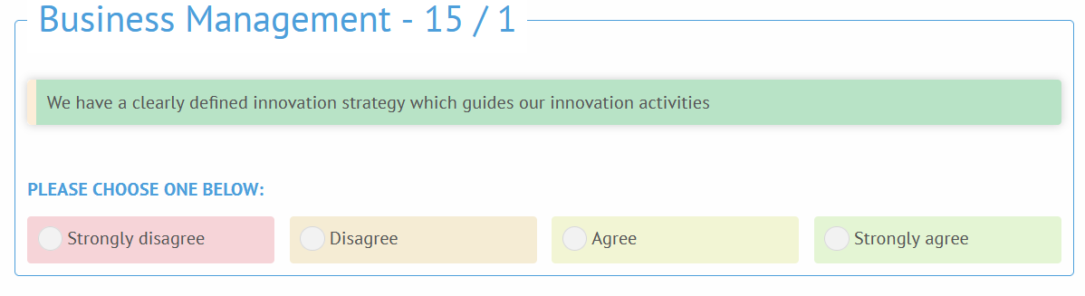

**Figure 1: Example Screenshot Showing the Self-assessment Statement and Rating Options**

After selecting the rating, the system advances to the next self-assessment statement by clicking on **NEXT** or **PREVIOUS** to move on. The statement counter shows how many statements you have rated (e.g. in the screenshot above 15/1).

**Step 3: The EPIC Self-Assessment Report**

The EPIC score for each Pillar (see end of the document) and converts them into an Index score as shown in Figure 2.

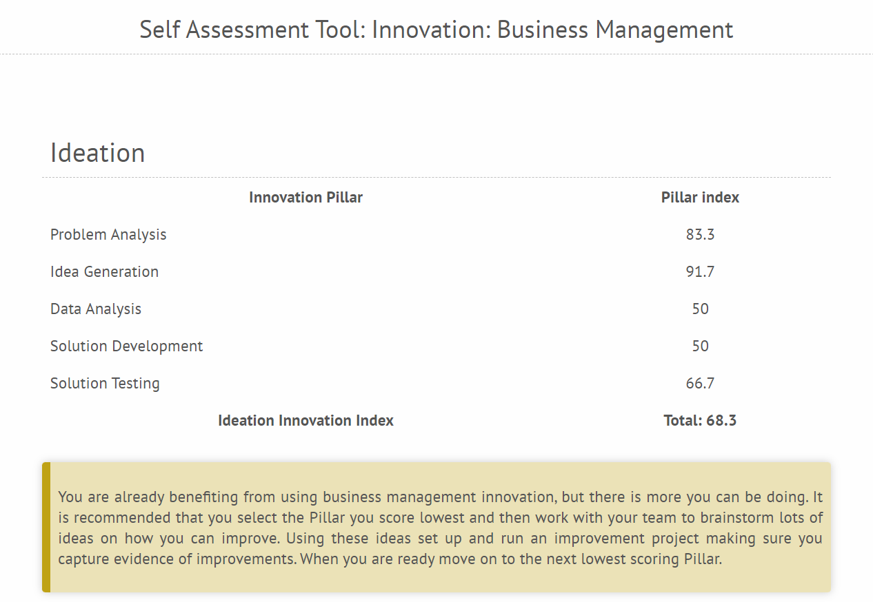

**Figure 2: Example Screenshot Showing the Self-assessment Score for Business Management**

The screen shows the overall Innovation Index (Core Skill) as 68.3 per cent. It also shows the individual Pillar Index scores (e.g. Problem Analysis as 83.3 per cent). Below this data within the EPIC system are also some charts which present the same data in a graphic format. The radar diagram shows your achievement compared to that of the others in your sector, and to the average of all the users. The bar chart shows the average achievement of the users of your company. You will also get an email informing you about your results.

**Step 4: Facilitator prompt sheets**

It helps to understand the self-assessment tools and the identified situation(s).

**Step 5: Providing Feedback on the Self-Assessment Report**

The report can be interpreted and discussed with the respondent. The aim of the feedback session is to explore areas for development and improvement and areas of strength which can be further developed.

**Step 6: The EPIC Route MAP (development templates)**

To maximise the value of the EPIC Self-assessment, it is suggested that the Facilitator agrees on an action plan (Route Map and Roadmap) with the respondent. You can find templates at the end of the assessments, as downloadable documents.

**Step 7: Action Plan Review and Repeat Self-assessment**

It is good practice for the Facilitator to support respondents to implement their action plan. It is also helpful to hold a follow-up meeting with respondents to review progress including repeating the EPIC Self-assessment to measure improvements and to identify any on-going development needs.

**The EPIC Skill Assessment Model**

The EPIC Assessment System is designed to help managers and organisations to improve their approach to innovation. The EPIC Model is based on five Core Skills subdivided into twenty-five Innovation Pillars. The Figure below shows the overall structure of the EPIC Model.

|  |  |
| --- | --- |
| **Core Skill** | **Innovation Pillar** |
| **Business Management** | **Business Goals and Objectives** |
| **Innovation Strategy** |
| **Risk Management** |
| **Resource Management** |
| **Project Management** |
| **Communication** | **Change cycle** |
| **Teams and Collaboration** |
| **Innovation Culture** |
| **Top-Level Commitment** |
| **Listening** |
| **Ideation** | **Problem Analysis** |
| **Idea Generation** |
| **Data Analysis** |
| **Solution Development** |
| **Solution Testing** |
| **Innovation** | **Innovation Process** |
| **Innovation Techniques** |
| **Innovative Thinking** |
| **Continuous Improvement** |
| **Innovative Culture** |
| **Digitalisation** | **Business Processes** |
| **Products and Services** |
| **Sales and Service** |
| **Collaborative Working** |
| **Remote Working** |